Title: School Security System Using RFID

ABSTRACT:

Ensuring the safety of students in educational institutions is of prime importance. This study introduces and evaluates a school security system that uses radio frequency identification (RFID) technology. The system uses RFID identification cards issued to students to track entry and exit from the school premises. By swiping the RFID card, the system fixes the time and location, which facilitates efficient tracking of student movements. Notifications are automatically sent to parents or guardians, improving communication and awareness. This article discusses the methodology, implementation process and technology behind RFID, and provides an overview of the system's architecture and its integration into the school's existing infrastructure. The study also examines the impact of an RFID-based school security system on improving overall security measures based on privacy and ethical considerations. The results suggest a positive correlation between the adoption of this system and improved security protocols in educational institutions.

Keywords: RFID, School Security, Attendance Tracking, Student ID, SMS Notification, Campus Safety.

INTRODUCTION

In today's society, parents struggle with increasing concerns about the safety of their children, especially with the alarming increase in crimes and poor academic performances by students. The prevailing socio-economic landscape, characterized by long working hours for parents, exacerbates these concerns as the time available for direct parental supervision decreases. One critical stage where these concerns converge is the period when children enter the classroom. It's not uncommon for bad guys to exploit this vulnerability and lure children in before they reach the safety of their facility. This alarming trend calls for a proactive, technology-based approach to school safety.

Aware of the importance of these challenges, schools have an important responsibility to ensure the safety of their students. In addition to providing quality education, schools must prioritize measures that ensure the physical well-being of their schools. This includes student tracking mechanisms and monitoring; place, especially at critical times such as entering and leaving school. In addition, it is important that schools create effective communication channels with parents and keep them informed about their children and activities at school. In response to these urgent issues, the proposed School Security System (SSS) using Radio Frequency Identification (RFID) technology appears as a strategic solution. Using RFID, the system aims to improve student safety by providing a robust mechanism to track students entering and exiting the school environment. With this technological innovation, schools can not only reduce the risk of criminal activity, but also provide the ability to immediately alert parents if their child has missed important school lessons.

This study explores the concept, design and implementation of an RFID-based school security system and is an important step towards strengthening the security infrastructure of educational institutions. Later sections of this document discuss the system's architecture, its goals, benefits, and possible future improvements, and provide a comprehensive overview of its relevance to today's school security challenges.

OBJECTIVES:

The goals of implementing an RFID-based school security system are multifaceted and aim to address various challenges related to student safety and parental concerns. At the forefront of the system, the goal is to increase the safety of students by enabling real-time monitoring of their movements in school premises. Using radio frequency identification (RFID) technology, the system ensures accurate tracking of students’ in-time and out-of-time, which strengthens the general security in the educational institution. Along with enhanced security measures, the system aims to optimize attendance monitoring.

Automating this process with RFID readers not only eliminates errors associated with manual methods, but also provides a smooth and efficient way to track student attendance. This goal promotes the creation of a safe and orderly environment that promotes effective teaching and learning. Effective communication is the core of the system and goals. The purpose of the RFID-based school security system is to create real-time communication channels between schools and parents through automatic text messages (Short Message Service). Parents receive instant updates on their child's attendance and activities, addressing concerns and building trust in the school and commitment to student welfare. This goal recognizes the critical role of parental involvement in ensuring the overall well-being of students.

Another main goal of the system is to streamline the free administrative processes. By creating a user-friendly interface for parents to request time off online, the system simplifies the communication channel between parents and schools. This not only reduces the administrative burden, but also ensures a transparent and documented process for managing student absences. In addition to immediate security and communication concerns, the aim of the system is to encourage the participation of parents in the education of their children.

A user-friendly interface for parents encourages active participation, allowing them to track their child's progress, request time off and stay updated on important school activities. Reducing unauthorized absences is an important part of the system and goals. Automated reminders act as a deterrent and encourage students to follow attendance rules. At the same time, this function ensures that parents are immediately notified if their child is not accounted for during school hours, promoting accountability and solving independent problems.

The system and goals extend to creating a friendly interface for both school administrators and parents. This user interface enables seamless interaction with the system, ensuring accessibility and ease of use for all stakeholders. Prioritizing user-friendliness, the system becomes a practical tool that can be effectively used in various educational environments. In addition, the system aims to promote a safety culture in educational institutions.

An RFID-based school security system, deploying advanced information security and communication technology, creates a platform to create an environment where students feel safe, parents are reassured, and schools actively invest in the safety of their students. .

Adaptability is an important part of the system and its goals. By preparing the basis for future improvements, such as integrating advanced security functions or scaling to larger institutions, the system ensures its relevance in the face of evolving security challenges.

In short, the goals of an RFID-based school security system are not only the immediate security and communication needs, but also the broader vision of promoting parental involvement, reducing unauthorized absences, promoting a culture of safety and adapting to future improvements. Together, these goals foster the creation of a safe, effective, and engaging learning environment that prioritizes student well-being.

LITERATURE REVIEW:

|  |  |  |  |  |  |  |  |
| --- | --- | --- | --- | --- | --- | --- | --- |
| Year | Author | Country | Objective | Contribution |  | Method | Conclusion |
| 2013 | Ankita Agrawal, A. Bansal | India | Online attendance system using RFID with object counter. | To provide an effective means of taking attendance by scanning QR codes. |  | Web service for  management system during which we have got work on the premise of presence of scanning the QR code with scanner. | The system proved very much effective in a more faster and convenient way. |
| 2017 | Pushpa S., Priyanka A.S, Sagar S. Bhave | India |  |  |  |  |  |
| 2015 | Moth Mymt, Chaw Myat |  |  |  |  |  |  |
| 2014 | **Unnati A Patel, Dr Swami Narayan,Priya R** |  |  |  |  |  |  |
| 2009 | **T.S. Lim, S.C. Sim and M.M. Mansor** | India | to produce security to the college  students. | RFID Based Attendance System |  | Take attendance for students in class, college, and university. | This proved easier, faster and secure than traditional methods. |

SYSTEM ARCHITECTURE:

The system architecture of the RFID-based school security system is designed to seamlessly integrate radio frequency identification technology (RFID) into the existing infrastructure of educational institutions. The architecture includes core components that work together to provide effective presence monitoring, communication and enhanced security.

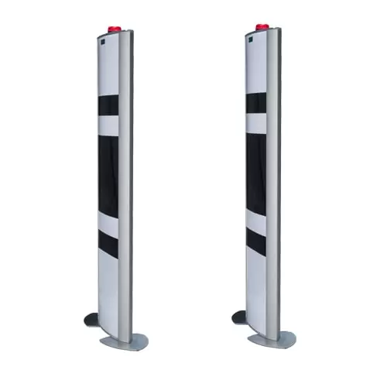**RFID Readers:** At the heart of the system are RFID readers strategically placed at the entrance and exit points of the school. These readers record and register students’ arrival and exit time. RFID tags make it possible to precisely monitor their movements in school premises.

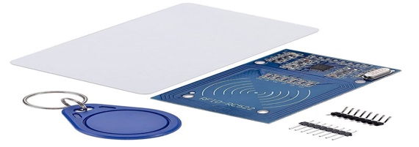**RFID tags:** attached to each student and ID card contain unique identification information that facilitates the tracking of individual students as they move around the school environment. Information stored on RFID tags includes student IDs, class information, and other related information.

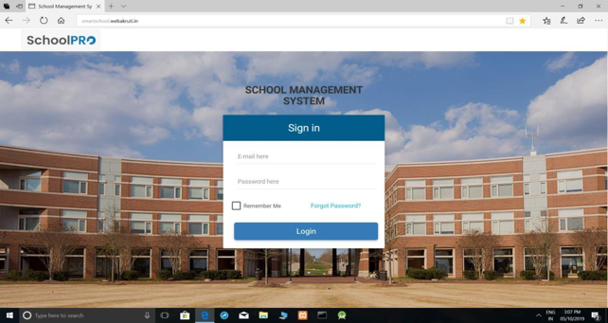**Web-Based System:** acting as a central hub for the school's security system. This system receives and processes data from RFID readers in real time. It provides a secure and user-friendly interface for school administrators to access attendance data, manage leave requests and generate reports. The web-based system acts as the backbone of real-time communication with parents and ensures timely knowledge of the activities of the child and the school.

**SMS gateway:** is integrated into the web-based system. This gateway is responsible for sending automatic SMS notifications to parents to trigger attendance records and absence requests. Integrating this communication channel ensures that parents receive real-time feedback.

**Database:** A strong database is essential for student information, attendance information and communication information from parents and to manage.

The database is connected to a web-based system that ensures smooth data flow and secure archiving of sensitive information. The system also includes special interfaces for both parents and school administrators in the web-based system.

**Leave Management:** These user interfaces provide secure login mechanisms and intuitive navigation to access participant data, leave management functions and other related information. In addition, the implementation of the leave management module simplifies the processing of leave requests within the system. Parents can submit requests online, and the module facilitates the approval and processing of these requests by school administrators, reducing administrative costs and ensuring a transparent communication channel.

The seamless interaction of these components ensures the seamless operation of an RFID-based school security system, providing schools and parents with a comprehensive tool to improve student safety and communication. Using RFID technology and web-based infrastructure, the system achieves its goals of effective attendance tracking, real-time parent engagement and improving the safety of the school environment. .

IMPLEMENTATION:

**RFID Infrastructure Setup:**

Implementation of an RFID-based school security system involves extensive integration of hardware and software components. In the initial phase, the focus is on the establishment of the RFID infrastructure and the strategic placement of RFID readers at the most important entrance and exit points of the school premises. At the same time, RFID tags are embedded in each student's ID cards, which contain unique identification information important for accurate tracking.

**Database Configuration:**

Database configuration is an important step to ensure offline storage and management of student information, attendance information, and parent communication. Establishing database connections to a web-based system facilitates the flow of real-time information. Developing a web-based system is an important part of the implementation process. This system acts as a central hub that receives and processes data from RFID readers. The development includes secure login mechanisms for both school administrators and parents, which ensures authenticated access to the system. Integration of RFID readers into a network system follows suit, enabling real-time data transmission.

**Web-Based System Development:**

To facilitate the communication between the RFID readers and the central database, protocols were established to ensure the accuracy of participant tracking. Adding an SMS gateway to your web-based system is an important step in enabling automatic SMS notifications. The system is scheduled to trigger SMS notifications based on attendance records and leave requests, providing parents with real-time updates on their children and school activities. Both parents and school administrators developed and implemented their own user interfaces in the web-based system.

**Integration of RFID Readers with Web System:**

The entire system, including the integration between the RFID readers, the web-based system and the SMS gateway, is reviewed to ensure smooth functionality. Trainings are organized for school administrators and parents to get used to the functionality of the RFID-based school security system. Deployment is controlled and may begin with a testing phase to address unexpected challenges. Continuous maintenance has been established to deal with any problems that may arise after deployment.

Regular updates and additions are planned to adapt the system to changing information security needs and technological developments, which ensures its longevity and effectiveness. The deployment process is a collaborative effort between IT professionals, school administrators and parents who work together to successfully integrate an RFID-based school security system into the educational environment. .

BENEFITS:

Implementation of an RFID-based school security system involves extensive integration of hardware and software components. In the initial phase, the focus is on the establishment of the RFID infrastructure and the strategic placement of RFID readers at the most important entrance and exit points of the school premises. At the same time, RFID tags are embedded in each student's ID cards, which contain unique identification information important for accurate tracking.

Database configuration is an important step to ensure offline storage and management of student information, attendance information, and parent communication. Establishing database connections to a web-based system facilitates the flow of real-time information. Developing a web-based system is an important part of the implementation process. This system acts as a central hub that receives and processes data from RFID readers. The development includes secure login mechanisms for both school administrators and parents, which ensures authenticated access to the system.

Integration of RFID readers into a network system follows suit, enabling real-time data transmission. To facilitate the communication between the RFID readers and the central database, protocols were established to ensure the accuracy of participant tracking. Adding an SMS gateway to your web-based system is an important step in enabling automatic SMS notifications. The system is scheduled to trigger SMS notifications based on attendance records and leave requests, providing parents with real-time updates on their children and school activities. Both parents and school administrators developed and implemented their own user interfaces in the web-based system. These user interfaces provide secure login mechanisms and intuitive navigation to access participant data, leave management functions and other related information.

The development of the leave management module makes it easier to process requests for parental leave. This system-integrated module facilitates the submission and processing of leave requests online, reduces administrative costs and ensures a transparent communication channel between parents and schools. Testing is done extensively to identify and correct any defects or problems that may occur after deployment. The entire system, including the integration between the RFID readers, the web-based system and the SMS gateway, is reviewed to ensure smooth functionality. Trainings are organized for school administrators and parents to get used to the functionality of the RFID-based school security system.

Deployment is controlled and may begin with a testing phase to address unexpected challenges. Continuous maintenance has been established to deal with any problems that may arise after deployment. Regular updates and additions are planned to adapt the system to changing information security needs and technological developments, which ensures its longevity and effectiveness. The deployment process is a collaborative effort between IT professionals, school administrators and parents who work together to successfully integrate an RFID-based school security system into the educational environment. .

Administratively, the RFID-based school security system optimizes the processes of educational institutions. Automating attendance tracking and communication channels reduces the administrative burden, allowing school staff to focus their efforts on more strategic and value-producing tasks. This not only increases administrative efficiency, but also contributes to a smoother and more efficient school management system. In addition, the system promotes a safety culture in educational institutions.

Using advanced technology for security and communication, an RFID-based school security system lays the foundation for creating an environment where students feel safe, parents are reassured, and schools actively prioritize the safety of their students. This proactive approach to safety creates a positive and conducive atmosphere for effective teaching and learning. In short, an RFID-based school security system offers a wide array of benefits.

From improved student security and optimized attendance tracking to smoother communication channels and greater parental involvement, the system has a positive impact on various aspects of educational institutions. As schools continue to embrace technological innovation, an RFID-based school security system demonstrates the transformative potential of technology in education, helping to create safe, effective and engaging learning environments.

CONCLUSION:

In conclusion, an RFID-based School Security System (SSS) is a key solution for student safety, parental anxiety and the need for effective management processes in educational institutions. The introduction of this system represents a proactive step towards using technology to create a safe and supportive learning environment. Thanks to RFID (Radio Frequency Identification) technology, SSS offers students a strong mechanism and #039; during and outside the school premises. Real-time communication enabled by automated text messages increases parental awareness and fosters collaboration between schools and parents to keep students safe.

The system not only simplifies attendance tracking, but also optimizes administrative processes, allowing school personnel to focus on strategic tasks instead of manual recording. An effective vacation management module further promotes a transparent and streamlined communication channel between parents and schools. In addition, SSS goes beyond immediate security aspects by promoting a culture of security in educational institutions. The adaptability of the system allows for future improvements, ensuring its relevance in the face of evolving security challenges.

As schools strive to create an environment that prioritizes the holistic well-being of students, an RFID-based school security system is a testament to the transformative possibilities of technology in education. By addressing parent concerns, promoting effective communication, and fostering a safe school environment, this system lays the foundation for a safer, more connected educational experience for both students and their families. By learning about such innovative solutions, educational institutions can play a key role in building a foundation for learning that extends beyond academic excellence to include broader aspects of student well-being and safety. .

FUTURE DIRECTION:

In the future, the RFID-based school security system offers opportunities for further development and improvement. Possible directions include integrating advanced security features such as video surveillance and exploring biometric authentication methods to increase student identification. The development of a mobile application for convenient use on the go and the inclusion of artificial intelligence algorithms to obtain predictive information are also promising areas.

Geo-fencing technology for school buses can be considered to ensure real-time tracking and security during transport. In addition, an evaluation of scalability should be done to adapt the system to larger educational institutions, while the creation of an integrated emergency response system could improve emergency management. Collaboration with law enforcement agencies can be explored to facilitate information sharing during emergencies, and continued improvement of cybersecurity measures is critical to protecting sensitive student information.

User feedback mechanisms can provide valuable information for system improvement, ensuring continuous adaptation to stakeholder needs. Community awareness programs can be initiated to educate parents, students and school staff about the benefits of an RFID-based school security system, promoting understanding and support for its role in creating a safer educational environment. By embracing these future directions, the system can evolve into a dynamic and adaptive solution that effectively meets today's challenges by preventing and mitigating new threats to school security. .